**11.ReactJS-HOL**

**Currency convertor:**

**CODE:**

**App.js:**

import React, { useState } from 'react';

import CurrencyConvertor from './CurrencyConvertor';

function App() {

const [count, setCount] = useState(0);

const increment = () => {

setCount(prev => prev + 1);

};

const sayHello = () => {

alert("Hello! This is a message after increment.");

};

const handleIncrement = () => {

increment();

sayHello();

};

const decrement = () => {

setCount(prev => prev - 1);

};

const sayWelcome = (msg) => {

alert(msg);

};

const handleClick = (e) => {

alert("I was clicked (Synthetic Event)");

console.log(e); // SyntheticEvent object

};

return (

<div style={{ padding: '20px' }}>

<h1>React Events Example</h1>

<h2>Counter: {count}</h2>

<button onClick={handleIncrement}>Increment</button>

<button onClick={decrement}>Decrement</button>

<hr />

<button onClick={() => sayWelcome("Welcome to the Event Handling App!")}>Say Welcome</button>

<hr />

<button onClick={handleClick}>Synthetic Event Button</button>

<hr />

<CurrencyConvertor />

</div>

);

}

export default App;

**index.js:**

import React from 'react';

import ReactDOM from 'react-dom/client';

import App from './App';

const root = ReactDOM.createRoot(document.getElementById('root'));

root.render(<App />);

**CurrencyConvertor.js:**

import React, { useState } from 'react';

function CurrencyConvertor() {

const [rupees, setRupees] = useState('');

const handleChange = (e) => {

setRupees(e.target.value);

};

const handleSubmit = () => {

const euro = (parseFloat(rupees) / 90).toFixed(2); // Assume 1 EUR = ₹90

alert(`Equivalent Euro: €${euro}`);

};

return (

<div>

<h2>Currency Convertor (INR → EUR)</h2>

<input

type="number"

placeholder="Enter amount in INR"

value={rupees}

onChange={handleChange}

/>

<button onClick={handleSubmit}>Convert</button>

</div>

);

}

export default CurrencyConvertor;

**OUTPUT:**

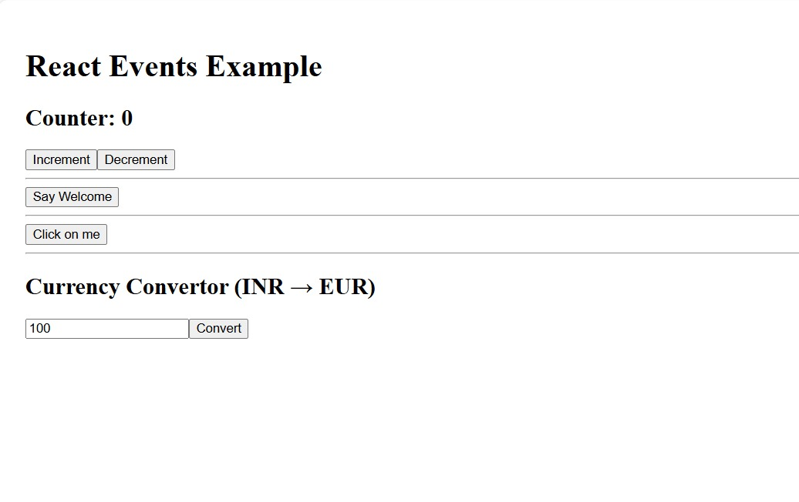

**Clicking Increment:**

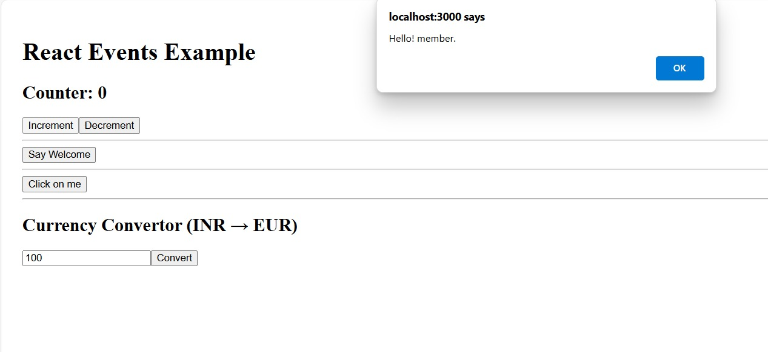

**Clicking say Welcome:**

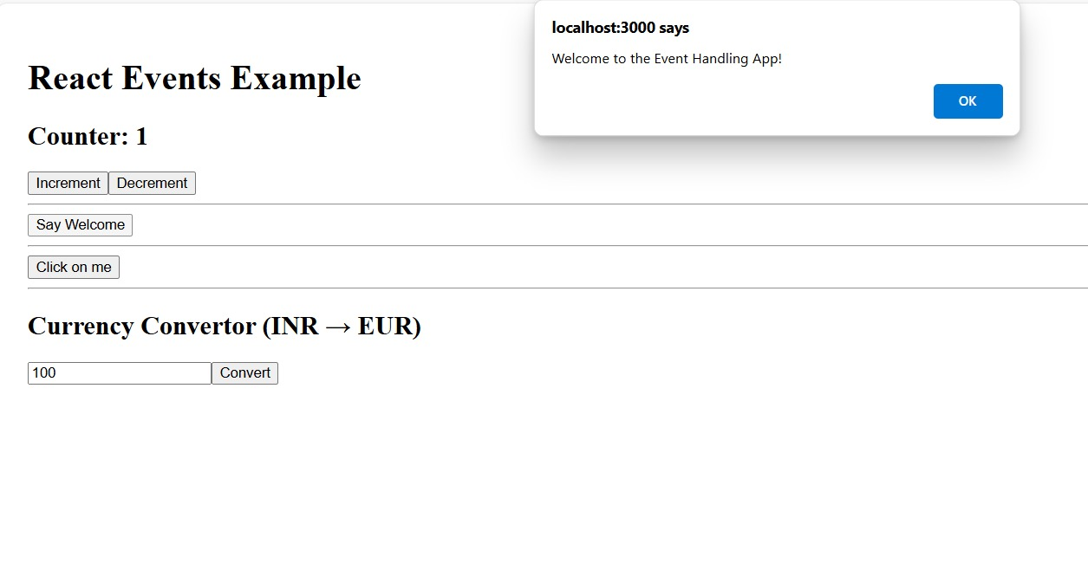

**Clicking click on me:**

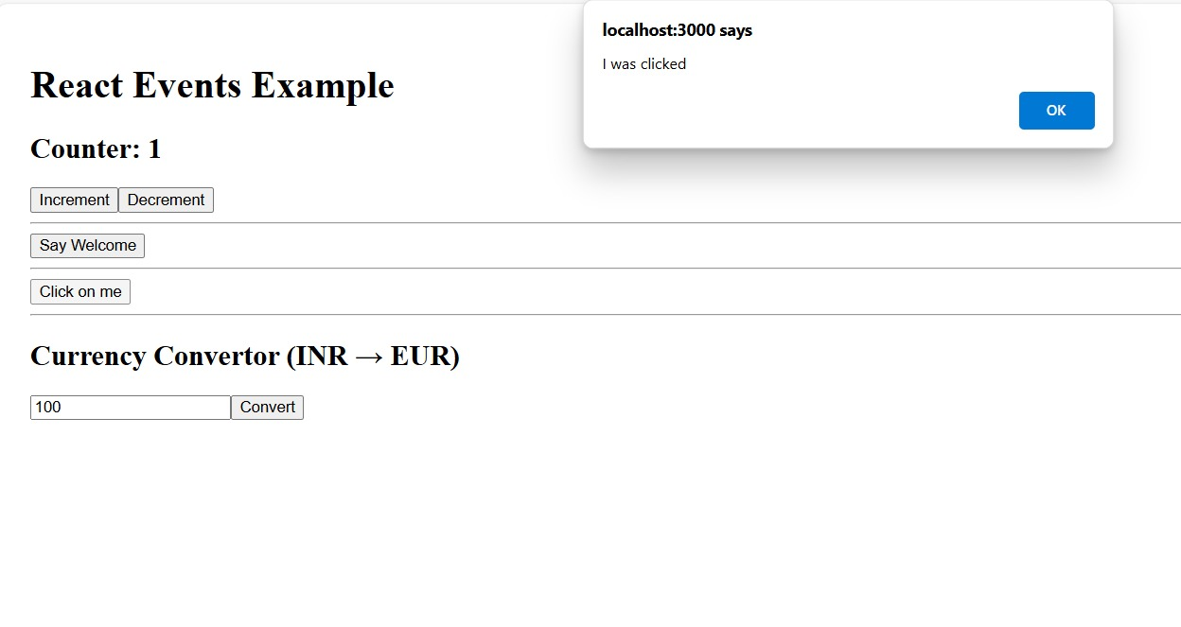

**Clicking convert:**

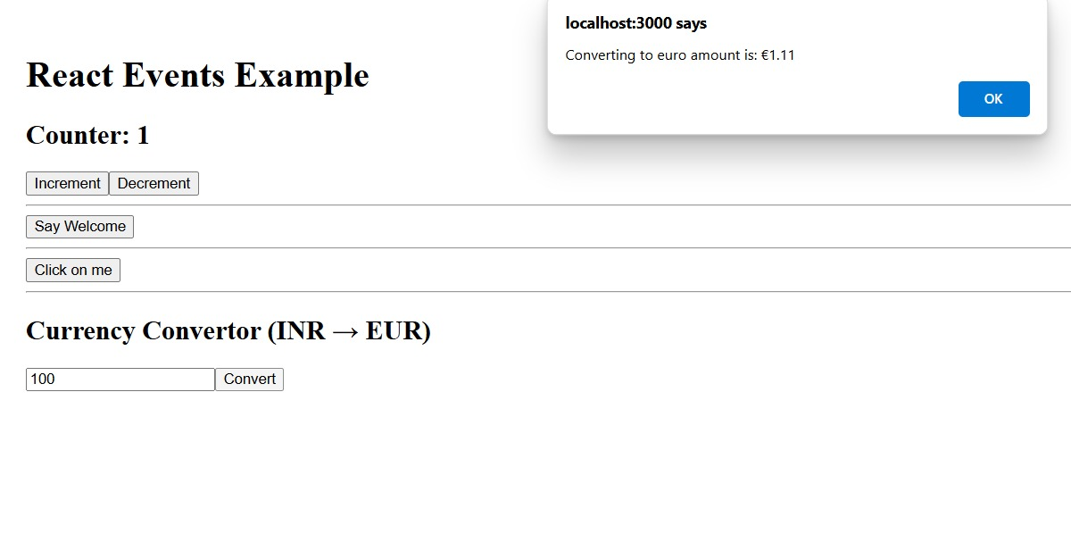

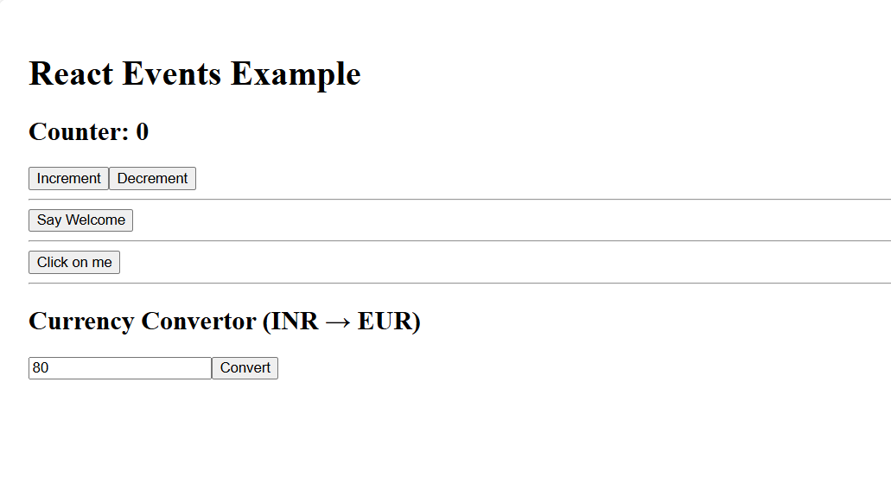**Clicking decrement:**